DESIGN AND IMPLEMENTATION OF A SMART TRAFFIC MANAGEMENT SYSTEM USING COMPUTER VISION

BY

IKPEN EFE JONATHAN

M.23/HND/CSC/11517

DEPARTMENT OF COMPUTER SCIENCE AND INFORMATION TECHNOLOGY
PETROLEUM TRAINING INSTITUTE
EFFURUN, DELTA STATE.

SEPTEMBER, 2025.

DESIGN AND IMPLEMENTATION OF A SMART TRAFFIC MANAGEMENT SYSTEM USING COMPUTER VISION
BY

IKPEN EFE JONATHAN
M.23/HND/CSC/11517

IN PARTIAL FULFILLMENT OF THE REQUIREMENTS FOR THE AWARD OF HIGHER NATIONAL DIPLOMA (HND) IN COMPUTER SCIENCE AND INFORMATION TECHNOLOGY DEPARTMENT

PETROLEUM TRAINING INSTITUTE EFFURUN,
PMB 20, EFFURUN,
DELTA STATE
NIGERIA

SEPTEMBER, 2025.

CERTIFICATION
This is to certify that this project research work was carried out by IKPEN EFE JONATHAN (M.23/HND/CSC/11517) of the Department of Computer Science and Information Technology, Petroleum Training Institute, Effurun, Delta State.

____________________ ____________________
IKPEN EFE JONATHAN DATE
STUDENT

APPROVAL
This is to certify that this project research work was carried out by IKPEN EFE JONATHAN (M.23/HND/CSC/11517) of the Department of Computer Science and Information Technology, Petroleum Training Institute, Effurun. Under the supervision of:

____________________ ____________________
DR. (MRS.) I.V. NGONADI Date
PROJECT SUPERVISOR

____________________ ____________________
DR. (MRS.) I.V. NGONADI Date
HEAD OF DEPARTMENT

DEDICATION
This project is dedicated to the Almighty God for his undeserved kindness, grace, blessings, and love during this research and throughout my Higher National Diploma at the institute.

ACKNOWLEDGMENT
I would like to express my sincere gratitude to my supervisor, Dr. (MRS.) IV. Ngonadi, the Head of the Department of Computer Science and Information Technology, who is also my supervisor, for her love, support, and patience with me over the duration of this project. God will bless the work of your heart and grant you your heart’s desires. The academic and non-academic staff of the Computer Science and Information Technology Department deserve my gratitude; thus, I would like to take this opportunity to do so. Most significantly, I want to express my gratitude to God Almighty for giving me the grace to complete my Higher National Diploma program at Petroleum Training Institute successfully.

TABLE OF CONTENT
TITLE PAGE
CERTIFICATION
DEDICATION
ACKNOWLEDGEMENT
TABLE OF CONTENT
ABSTRACT
CHAPTER ONE: INTRODUCTION
  - Background of the Study
  - Statement of the Problem
  - Aim and Objectives of the Study
    - Aim of the Study
    - Objectives of the Study
  - Scope of the Study
  - Significance of the Study
  - Limitations of the Study
CHAPTER TWO: LITERATURE REVIEW
  - Introduction
  - Theoretical Framework
    - Singapore’s Intelligent Transport System (ITS)
    - Los Angeles Adaptive Traffic Control System
    - Smart Traffic Solutions in India
  - Brief Historical Development of Traffic Management
  - Conventional Traffic Management Systems
  - Types of Smart Traffic Management Systems
    - Adaptive Traffic Signal Control Systems
    - Surveillance-Based Traffic Management
    - Multimodal Traffic Systems
  - Emerging Smart Traffic Management Systems
    - Features of the Emerging Systems
    - Computer Vision’s Role
  - Benefits of Smart Traffic Management
  - Challenges in Smart Traffic Management
CHAPTER THREE: METHODOLOGY AND SYSTEM ANALYSIS
  - Introduction
  - Adopted Method for this Research
  - Data Gathering
  - Problem Identification
  - Feasibility Studies
  - Analysis of the Present System
    - Present Procedure for Traffic Management
    - Merits of the Existing System
    - Demerits of the Existing System
    - Data Flow Diagram of the Existing System
  - Analysis of the Proposed System
    - Proposed Procedure for Smart Traffic Management
    - Merits of the New System
    - Demerits of the New System
    - Justification of the New System
    - Data Flow Diagram of the Proposed System
CHAPTER FOUR: SYSTEM DESIGN AND IMPLEMENTATION
  - Introduction
  - Design Considerations
  - Flowchart of the System
  - Use Case Description
  - Processing and System Modules Design
    - Vehicle Detection Module
    - Signal Switching Algorithm
    - Simulation Module
    - Graphical User Interface (GUI) Module
  - Database Design
  - System Environment Specifications
    - Hardware Requirements
    - Software Requirements
  - Implementation Stages
    - System Initialization
    - Vehicle Detection Module
    - Signal Switching Algorithm
    - Simulation Module
    - Graphical User Interface (GUI) for Detection
  - User Training Stage
  - Interface of the System
    - Graphical User Interface (GUI) for Vehicle Detection
    - Simulation Interface (PyGame)
  - Testing
CHAPTER FIVE: SUMMARY, CONCLUSION, AND RECOMMENDATION
  - Introduction
  - Summary
  - Conclusion
  - Recommendations
REFERENCES
APPENDIX A – “SOURCE CODE – VEHICLE DETECTION MODULE”
APPENDIX B – “SOURCE CODE - SIMULATION”

LIST OF FIGURES

Figure 3. 1: Dataflow diagram of the present system 1
Figure 3. 2: Dataflow diagram of the proposed system 1

Figure 4. 1: Proposed System Operation Flowchart 1
Figure 4. 2: Real-time Vehicle Detection Dashboard 1
Figure 4. 3: Simulation of Traffic System 1

ABSTRACT
Traffic congestion has become one of the most persistent challenges of urban transportation, causing delays, fuel wastage, and environmental pollution. Traditional fixed-time traffic lights are inefficient because they cannot adapt to fluctuating traffic volumes. This project presents the design and implementation of a smart traffic management system using computer vision to intelligently regulate traffic flow based on real-time conditions. The system employs a pre-trained YOLO object detection model to identify and count vehicles from images and videos, categorizing them into cars, bikes, buses/trucks, and rickshaws. An adaptive signal timing algorithm was developed to compute green light durations proportionally to the number and type of vehicles detected, ensuring balanced traffic flow across all directions. A simulation environment built with Pygame demonstrates the adaptive signal operation at a four-way intersection, while a graphical user interface (GUI) allows users to perform detection and analysis interactively. Testing showed that the system successfully adapts signal durations based on traffic density and provides a flexible, cost-effective prototype for smart city traffic control applications. This work proves that integrating computer vision and algorithmic intelligence into traffic management can enhance road efficiency, reduce congestion, and serve as a practical model for intelligent urban mobility systems.

CHAPTER ONE
INTRODUCTION
  - BACKGROUND OF THE STUDY
Traffic congestion has become a significant issue in urban areas worldwide, leading to increased travel times, environmental pollution, and higher accident rates. The rapid pace of urbanization and the growing number of vehicles have intensified this issue, especially in densely populated cities. According to the Texas A&M Transportation Institute's Urban Mobility Report (2021), traffic congestion in the United States alone results in annual losses exceeding $166 billion due to wasted fuel and time. This problem is global, with similar traffic issues affecting cities across Europe, Asia, and Africa, leading to economic losses and reducing the quality of life in urban centers (Schrank et al., 2021).

Traditional traffic management systems, which primarily use fixed signal timings, often fail to respond dynamically to real-time traffic conditions. These limitations become particularly evident during off-peak hours or in cases of sudden incidents, where traffic can accumulate or be delayed unnecessarily. As urban traffic patterns grow more complex, these inefficiencies highlight the need for adaptive solutions (Jiang & He, 2019).

Recent technological advancements, particularly in computer vision and machine learning, have opened new avenues for improving traffic management. By enabling systems to "see" and analyze real-time traffic data, computer vision allows traffic systems to adapt dynamically to varying traffic conditions. Smart traffic management systems can use camera feeds or image inputs to detect vehicles, assess traffic density, and adjust signal timings, thereby reducing congestion and enhancing road safety and the overall efficiency of the road network (Kumar & Kumar, 2020).

This project explores the design and implementation of a smart traffic management system using computer vision technologies and simulation. By leveraging pre-trained YOLO-based vehicle detection models and simulating real-time traffic conditions in a custom-built Pygame environment, the system dynamically adjusts signal timings based on vehicle density and type. This study presents a feasible solution within the constraints of a student project, while demonstrating the principles of real-world adaptive traffic control.

1.2 STATEMENT OF THE PROBLEM
The rising rate of urbanization has intensified traffic congestion, causing numerous socioeconomic challenges, including lost productivity, increased stress, higher fuel expenses, increased travel times, higher accident rates, and environmental degradation. Traditional traffic management methods fail to adapt quickly to real-time changes in traffic flow, leading to inefficient traffic signal timing and increased congestion (Olaru & Mohor, 2018).
This study seeks to address these issues by developing a simplified smart traffic management system that utilizes computer vision to monitor traffic conditions and control signal timing based on vehicle density. This project demonstrates how an adaptive system can function effectively using image feeds, pre-trained detection models, and simulation without the need for complex infrastructure or high-cost resources.
  - AIM AND OBJECTIVES OF THE STUDY
    - AIM OF THE STUDY
The primary aim of this study is to DESIGN AND IMPLEMENT A SMART TRAFFIC MANAGEMENT SYSTEM USING COMPUTER VISION techniques to improve traffic flow and reduce congestion in urban areas.

    - OBJECTIVES OF THE STUDY
The objectives of this study are as follows:
- To develop a system that utilizes pre-trained computer vision models for vehicle detection and classification.
- To develop an adaptive traffic signal control algorithm that dynamically adjusts green signal time based on the detected traffic density and vehicle types.
- To simulate traffic flow and signal behavior at an intersection.
- To design a GUI-based interface for displaying detection results from traffic images and video feeds.

  - SCOPE OF THE STUDY
This study focuses on building a simulated smart traffic management system using vehicle detection and adaptive signal timing. The scope encompasses the implementation of the system’s components, including object detection models, traffic signal logic that adjusts based on vehicle count and types, and a Pygame-based traffic simulation. The study will be limited to processing pre-captured traffic images; the system does not incorporate real-time video feeds or integration with actual traffic hardware, but demonstrates the feasibility and effectiveness of such a system through simulation.

  - SIGNIFICANCE OF THE STUDY
The significance of this study lies in its potential contributions to the field of traffic management. By demonstrating a cost-effective, simulation-based approach to smart traffic management using computer vision, this project can serve as a stepping stone for further research and development in this area. Additionally, the findings may provide insights into how similar systems can be implemented in urban settings to improve traffic conditions
Moreover, this project highlights the importance of leveraging existing technologies in innovative ways, encouraging further exploration of smart city initiatives and the integration of advanced technologies into urban infrastructure.

  - LIMITATIONS OF THE STUDY
While this project aims to present a functional smart traffic management system, several limitations must be acknowledged:
- Real-time Limitations: The system uses image-based detection and simulated traffic rather than real-time camera feeds from actual intersections.
- Hardware and Performance: The project is designed to run on standard computing devices without specialized hardware.
- Scope of Implementation: The study does not include the integration of the system with existing traffic infrastructure or real-time traffic monitoring, limiting its practical applicability.
- Simplified Simulation: The simulation abstracts many real-world traffic complexities such as pedestrians, weather variations, and emergency scenarios.

CHAPTER TWO
LITERATURE REVIEW
  - INTRODUCTION
Traffic congestion and inefficiencies in traditional traffic management systems have led to significant interest in innovative solutions to optimize urban mobility. Smart traffic management systems are increasingly seen as a solution to these challenges. These systems integrate computer vision, artificial intelligence (AI), and Internet of Things (IoT) technologies to dynamically manage traffic flow, reduce congestion, and enhance safety. This chapter presents a detailed review of relevant literature, exploring theoretical frameworks, historical developments, conventional systems, emerging technologies, and their benefits. It also includes an in-depth analysis of existing smart traffic management systems as case studies.

  - THEORETICAL FRAMEWORK
The development of smart traffic management systems (STMS) is underpinned by various theoretical frameworks that focus on optimizing traffic flow, real-time decision-making, and leveraging advanced technologies for automation and efficiency. These frameworks combine aspects of computer vision, machine learning, and IoT to address specific challenges in urban traffic scenarios.

    - Singapore’s Intelligent Transport System (ITS)
Singapore’s ITS is a global benchmark for smart traffic management. Developed to address the country’s high population density and limited land space, ITS employs a combination of advanced technologies and policies to ensure efficient transportation. The system integrates electronic road pricing (ERP), video surveillance, and IoT-enabled traffic sensors. Real-time data collected from traffic cameras and road sensors are processed using predictive analytics to optimize traffic flow.
Key features include:
- Electronic Road Pricing (ERP): A dynamic toll system that adjusts rates based on traffic conditions, discouraging congestion during peak hours (Liu et al., 2020).
- Green Link Determining (GLIDE): An adaptive traffic signal control system that ensures minimal waiting times at intersections.
- Real-Time Traveler Information Systems: Mobile apps and information boards provide commuters with live updates on traffic conditions.
Studies have shown that ITS has reduced average travel times in Singapore by 20% and significantly lowered vehicular emissions (Liu et al., 2020).

    - Los Angeles Adaptive Traffic Control System
Los Angeles operates one of the largest adaptive traffic control systems (ATCS) in the world, known as ATSAC (Automated Traffic Surveillance and Control). This system manages over 4,500 intersections using a centralized computer system to monitor and adjust traffic signal timings in real time. ATSAC’s architecture includes:
- Video Monitoring: Cameras installed at intersections provide live feeds to the control center.
- Loop Detectors: Embedded in roadways, these sensors measure traffic flow and vehicle speeds.
- Machine Learning Algorithms: Data from sensors are analyzed to optimize signal timings and prioritize emergency vehicles.
A study by Shah et al. (2021) reported that ATSAC reduced congestion by up to 16% and saved commuters over 10 million gallons of fuel annually. The system’s scalability and flexibility make it a model for other cities aiming to adopt adaptive traffic control technologies.

    - Smart Traffic Solutions in India
India’s urban centers face unique challenges such as overcrowded roads, diverse vehicle types, and limited infrastructure budgets. Smart traffic management initiatives in India leverage low-cost technologies to address these issues. Examples include:
- Surat Traffic Management System: This system uses AI-driven CCTV cameras to monitor traffic and detect violations. Real-time data is processed to optimize traffic signals.
- Indore Intelligent Traffic System: A combination of RFID tags and automated number plate recognition (ANPR) systems are used to manage toll collection and monitor traffic density.
- Pune Smart Signals: AI algorithms analyze live traffic data to control signal durations dynamically, reducing average waiting times by 30% (Kumar & Kumar, 2020).
These solutions demonstrate the feasibility of implementing cost-effective smart traffic systems in developing countries. Studies highlight their potential to significantly improve traffic efficiency and reduce operational costs.

  - BRIEF HISTORICAL DEVELOPMENT OF TRAFFIC MANAGEMENT
The evolution of traffic management systems dates back to the introduction of manually operated traffic signals in the early 20th century. The introduction of the first automated traffic signal in Cleveland, Ohio, in 1914 marked a significant milestone. By the 1920s, automated traffic lights with fixed timing schedules were introduced in major cities. However, these systems lacked flexibility, leading to inefficiencies during fluctuating traffic conditions (Jiang & He, 2019).
In the 1960s, advancements in electronics brought inductive loop detectors, which could measure vehicle presence and traffic density. By the late 20th century, microprocessors and computer algorithms were integrated into traffic management systems, enabling semi-automated control of traffic signals. The 21st century marked the beginning of fully automated systems leveraging AI, IoT, and computer vision technologies to optimize traffic flow dynamically (Zhang et al., 2022).

  - CONVENTIONAL TRAFFIC MANAGEMENT SYSTEMS
Conventional traffic systems primarily rely on fixed signal timings and manual interventions to regulate traffic flow. These systems use technologies such as:
- Inductive Loop Sensors: Installed beneath road surfaces to detect the presence of vehicles based on magnetic field disruptions.
- Infrared Sensors: Used to monitor traffic density by counting vehicles.
- Manual Traffic Monitoring: Involving traffic wardens or operators overseeing intersections.
- Static Traffic Signal Timings: Predefined schedules for traffic lights, irrespective of real-time traffic conditions.
Although these systems are effective under stable traffic conditions, they struggle during peak hours or emergencies. For example, fixed-timing signals often result in unnecessary delays, as they cannot prioritize high-traffic lanes dynamically. Maintenance of physical sensors also adds to the operational cost and complexity, making these systems less viable for expanding urban environments (Shah et al., 2021).

  - TYPES OF SMART TRAFFIC MANAGEMENT SYSTEMS
Smart traffic systems can be categorized into various types based on their functionality and technology:
    - Adaptive Traffic Signal Control Systems
These systems dynamically adjust signal timings to minimize delays. For example, Singapore’s GLIDE system prioritizes public transport and emergency vehicles.
    - Surveillance-Based Traffic Management
These systems use cameras and AI to monitor traffic violations and manage incidents. They are widely implemented in urban areas to enhance safety.

    - 2.6.3 Multi-Modal Traffic Systems
These integrate data from multiple transport modes, such as buses, trains, and private vehicles, to optimize overall traffic flow. Examples include systems in Tokyo and London.

  - EMERGING SMART TRAFFIC MANAGEMENT SYSTEMS
The emergence of smart traffic management systems is revolutionizing the field by incorporating real-time adaptability and automation. These systems use advanced technologies such as IoT, machine learning, and computer vision to optimize traffic flow dynamically. Unlike their conventional counterparts, smart systems are capable of learning traffic patterns and making data-driven decisions.
    - Features of Emerging Systems:
- Real-Time Monitoring: Automated detection of vehicles, and pedestrians and continuous analysis of traffic conditions using video feeds.
- Dynamic Signal Control: Adjustment of traffic light timings based on real-time data.
- Traffic Prediction: Utilizing machine learning algorithms to predict congestion and preemptively optimize traffic flow (Zhang et al., 2022).
    - Computer Vision's Role:
Computer vision is a critical component of smart traffic systems. It involves analyzing video feeds to detect and classify objects such as vehicles and pedestrians. Pre-trained models like YOLO (You Only Look Once) and Faster R-CNN (Region-based Convolutional Neural Networks) have demonstrated high accuracy in real-world applications. These models can process visual data in real time, enabling smart systems to respond instantly to traffic changes (Redmon et al., 2016; Ren et al., 2017).

  - BENEFITS OF SMART TRAFFIC MANAGEMENT
The adoption of smart traffic systems offers numerous benefits, including:
- Reduced Congestion: Real-time monitoring and adaptive control minimize delays.
- Enhanced Safety: Automated systems detect and respond to accidents promptly.
- Environmental Benefits: Optimized traffic flow reduces fuel consumption and emissions.
- Cost-Effectiveness: Despite initial investment, operational costs are lower due to automation.
- Scalability: These systems can accommodate growing urban populations and evolving traffic patterns (Zhang et al., 2022).

  - CHALLENGES IN SMART TRAFFIC MANAGEMENT
Despite the advancements, several challenges hinder the widespread adoption of smart traffic systems:
- High Initial Costs: Implementing smart systems requires significant investment in hardware and software.
- Data Quality Issues: Real-time processing of video feeds can be affected by poor lighting, weather conditions, or obstructions.
- Computational Complexity: High-resolution video analysis demands substantial computational power, which may not be accessible in all regions.
- Privacy Concerns: The use of surveillance cameras raises ethical concerns regarding the privacy of individuals.
- Integration with Legacy Systems: Retrofitting existing infrastructure to support smart technologies can be costly and technically challenging (Zhang et al., 2022).

CHAPTER THREE
METHODOLOGY AND SYSTEMS ANALYSIS
  - INTRODUCTION
Methodology refers to the systematic, theoretical analysis of the methods applied to a field of study. In computer science and software development, it encompasses the framework of techniques, tools, and strategies used for planning, developing, and evaluating a software system. System analysis, on the other hand, refers to the process of studying the current system’s components, workflows, data flow, and operational requirements to identify areas for improvement and to design more efficient systems (Satzinger et al., 2015). This chapter presents the methodology adopted for designing and implementing a smart traffic management system using computer vision, and it provides a detailed comparative analysis between the current traffic system and the proposed adaptive system.

  - ADOPTED METHOD FOR THIS RESEARCH
The methodology adopted for this research project is the Waterfall model, a linear and sequential software engineering model where the output of one phase serves as input for the next. This model was chosen because it fits well with the nature of the research, where system requirements were known early, and each component—detection, algorithm, simulation—had to be implemented in sequence.
The system consists of the following core components:
- Vehicle Detection Module – Utilizes a YOLO (You Only Look Once) deep learning model to detect and classify vehicles in images (Redmon et al., 2016).
- Signal Switching Algorithm – A rule-based algorithm dynamically calculates and assigns optimal green signal times based on vehicle counts and estimated vehicle crossing times.
- Simulation Module – Visualizes real-time adaptive traffic flow at a four-way intersection using the Pygame library for the simulation.
This modular design supports the waterfall approach by clearly defining stages and deliverables for each phase of development.

  - DATA GATHERING
Data gathering was primarily based on two sources:
- Vehicle Image Dataset Creation: The training dataset for the vehicle detection model was created by scraping top-down images of traffic scenes from Google. These images were manually labeled using LabelIMG, a widely used open-source image labeling tool, to train the YOLO model to detect four classes: cars, bikes, heavy vehicles (buses and trucks), and rickshaws.
- Vehicle Dynamics and Signal Timing Factors: Secondary data regarding average speeds and crossing times of different vehicle types were obtained from studies such as Zhang et al. (2011), which analyzed vehicle behavior at urban intersections. These were critical for modeling how long each vehicle class would typically take to cross a junction under green light.
This data formed the basis for both the vehicle classification model and the adaptive timing logic.

  - PROBLEM IDENTIFICATION
The traditional fixed-time traffic signal systems allocate green signal durations in a uniform, cyclic manner. This rigid scheduling does not consider real-time vehicle flow, leading to inefficiencies, particularly in low-traffic or highly congested lanes (Gupta & Tiwari, 2017) such as when lanes with fewer vehicles receive the same green time as heavily congested lanes, wasting valuable time and contributing to unnecessary delays. Furthermore, such systems lack the flexibility to adapt to spontaneous changes such as emergency vehicles, road closures, or sudden surges in traffic flow. The root problem is the absence of intelligent, real-time responsiveness in the traffic signal system.
In essence, the identified problems are:
- Lack of adaptability to real-time traffic volume.
- Increased waiting time and fuel consumption.
- Inflexibility in responding to spontaneous congestion.
- Absence of prioritization based on vehicle types (e.g., emergency or heavy vehicles).

  - FEASIBILITY STUDIES
A feasibility study was conducted across several dimensions to ensure that the project was realistic and achievable within the context of a student research project:
- Technical Feasibility: Implementing the system using Python, OpenCV, Pygame, and a YOLO model was deemed technically viable. These tools are well-documented, have large developer communities, and run effectively on standard computing hardware.
- Economic Feasibility: No expensive hardware or costly data sources were required. The system relied on open-source libraries and pre-trained models, making it cost-effective and suitable for academic research.
- Operational Feasibility: The system can simulate traffic behavior, provide intelligent signal switching, and is easy to operate and test without the need for physical integration into live traffic systems.
- Time Feasibility: Given the academic calendar and available development hours, the project scope was achievable within the given timeline.
The results of the feasibility analysis indicated that the proposed system is viable and implementable within the scope of this academic research.

  - ANALYSIS OF THE PRESENT SYSTEM
    - PRESENT PROCEDURE FOR TRAFFIC MANAGEMENT
In the existing system, traffic lights operate on static pre-programmed cycles. Each direction is given a green light for a fixed amount of time in a round-robin fashion, regardless of the actual number of vehicles waiting. These systems use timers hardcoded into traffic light controllers and are typically set based on historical traffic data or empirical rules and lacks the ability to adjust in real time (Li et al., 2014). It assumes an equal distribution of traffic, which rarely reflects actual urban traffic flow patterns.
For example, a four-way intersection might allocate 30 seconds of green light to each direction, regardless of whether one lane is empty and another is heavily congested. The system does not adapt to real-time input and cannot dynamically allocate green time to prioritize busier lanes.

    - MERITS OF THE EXISTING SYSTEM
- Simplicity: The fixed-timer approach is easy to install and maintain due to fixed schedules.
- Predictability: Drivers become familiar with signal patterns, leading to smoother behavior at intersections.
- Low Infrastructure Requirement: No real-time sensors or computer vision systems are needed.

    - DEMERITS OF THE EXISTING SYSTEM
- Inefficiency: Green light time is wasted on lanes with little or no traffic.
- Lack of Real-time Responsiveness: Cannot adapt to emergencies or sudden traffic spikes.
- Higher Congestion and Fuel Wastage: Idling at red lights increases fuel consumption and pollution.
- No Prioritization: Vehicle types and lane congestion are not factored into signal timing. All vehicle types are treated equally, regardless of size and urgency.

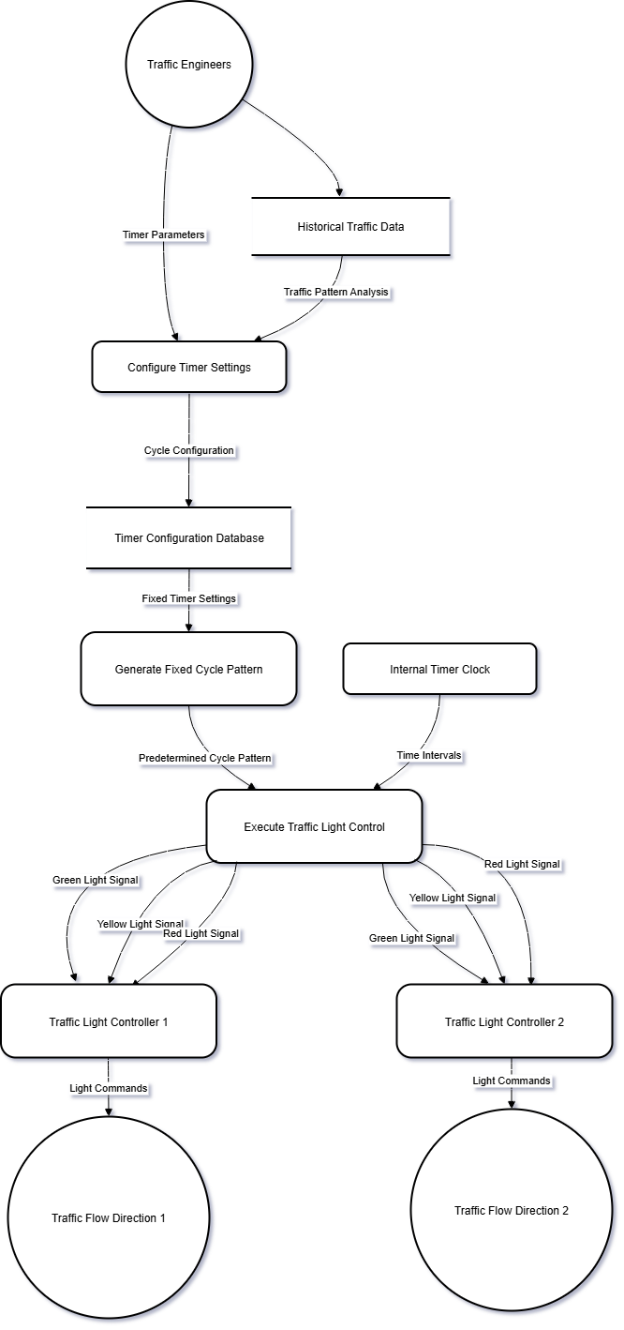
    - DATA FLOW DIAGRAM OF THE EXISTING SYSTEM

Figure 3. 1: Dataflow diagram of the present system
  - ANALYSIS OF THE PROPOSED SYSTEM
    - PROPOSED PROCEDURE FOR SMART TRAFFIC MANAGEMENT
The proposed system introduces intelligence into the traffic signal control loop through computer vision and algorithmic decision-making. Images from traffic junctions are processed using a YOLO-based model trained to detect and classify vehicles. The number and type of vehicles are extracted from the image, and the green light duration is calculated and assigned accordingly using a weighted average formula (Redmon et al., 2016; Zhang et al., 2011) that considers:
- The average time each vehicle class requires to cross.
- The number of lanes at the intersection.
- The minimum and maximum green signal limits.
The calculated green time is then used to update the signal timer dynamically. Signals rotate cyclically, maintaining familiar driver behavior patterns. However, unlike the static model, each lane’s green time is customized per cycle, minimizing time wastage and improving flow efficiency (Abdoos et al., 2014). The simulation runs in real time using Pygame, showing how the signals change and vehicles move accordingly.
The signal switching algorithm follows this logic:
- Red → Green → Yellow → Red
- Vehicle detection is triggered 5 seconds before a new green phase begins.
- Signal times are updated seamlessly in the background to prevent lag.

    - MERITS OF THE NEW SYSTEM
- Adaptability: Adjusts signal timing dynamically based on actual traffic load.
- Efficiency: Reduces congestion, unnecessary waiting, and fuel consumption.
- Realism: Considers vehicle types and average crossing time.
- Modular Design: Each system component can be modified or scaled independently.
- Visual Feedback: Simulation provides an intuitive understanding of system behavior.

    - DEMERITS OF THE NEW SYSTEM
- Simulation-Only: The system is not currently deployed in a real-world traffic environment.
- No Live Video Processing: Vehicle detection is based on image feeds, not live camera feeds.
- No Hardware Integration: It lacks live connectivity to traffic light controllers.
- Computational Demands: YOLO inference can be resource-intensive on low-end systems..

    - JUSTIFICATION OF THE NEW SYSTEM
Despite its limitations, the new system represents a significant improvement over traditional models. It introduces intelligence to the traffic control process using only low-cost software tools. The integration of object detection and dynamic signal assignment offers a compelling case for smarter traffic systems. Research shows that adaptive systems reduce average delay time and improve traffic throughput compared to fixed systems (Djahel et al., 2015). The proposed system provides a simulation-based prototype that demonstrates how low-cost, vision-based solutions can improve urban mobility. Furthermore, the simulation module visually demonstrates the potential benefits of such a system and can serve as a prototype for future deployment in smart cities. It lays the groundwork for incorporating live video feeds, edge devices, and sensor integration in future iterations.

    - DATA FLOW DIAGRAM OF THE PROPOSED SYSTEM

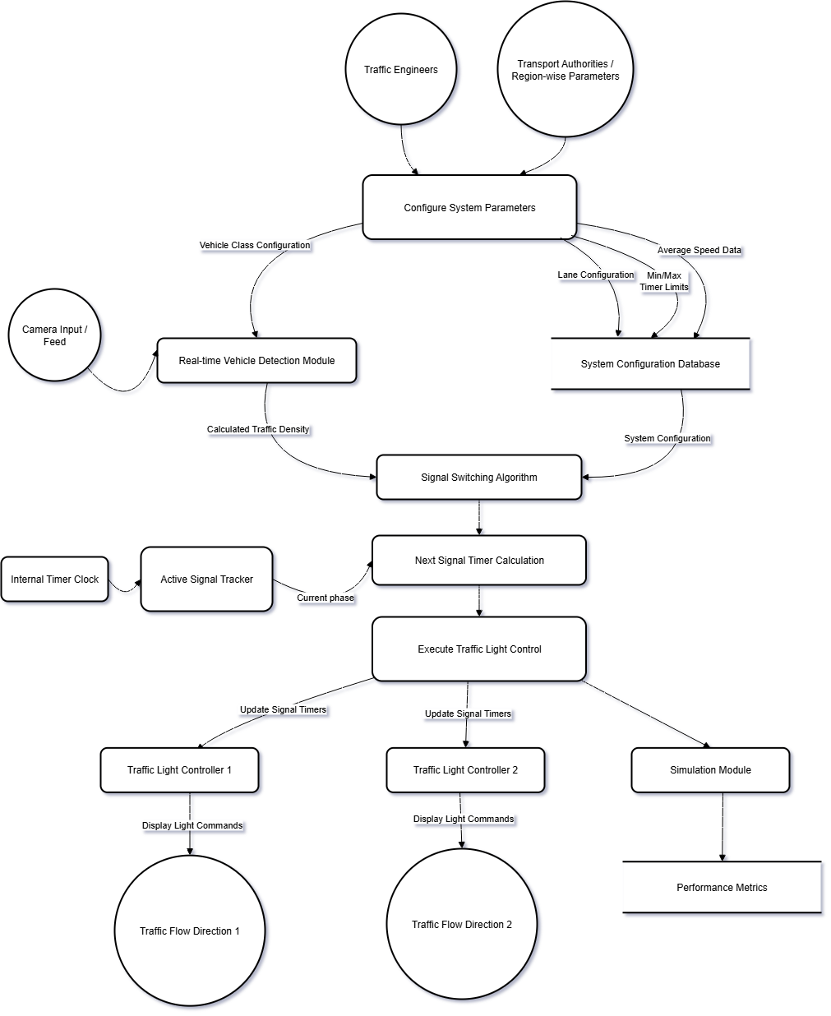
Figure 3. 2: Dataflow diagram of the proposed system

CHAPTER FOUR
SYSTEM DESIGN AND IMPLEMENTATION
4.1 INTRODUCTION
This chapter focuses on the design and implementation of the smart traffic management system developed in this research. The primary objective of the project is to provide an adaptive traffic signal timer capable of detecting vehicles using computer vision, analyzing traffic density, and dynamically adjusting traffic light durations. The chapter discusses the system design considerations, flowcharts, use-case diagrams, system environment specifications, stages of implementation, user training, the interface of the developed system, and testing procedures. Each aspect of the chapter is explained in detail to ensure a comprehensive understanding of how the system was constructed and how it operates.
The system has been implemented in modular components—vehicle detection, signal switching algorithm, simulation, and graphical user interface (GUI) for image and video-based vehicle detection. Together, these modules form an integrated framework that demonstrates how computer vision can improve traditional fixed-timer traffic systems.

4.2 DESIGN CONSIDERATIONS
The design of the system was guided by both functional and non-functional requirements to ensure efficiency, usability, and scalability. The following considerations were made during the design phase:
i. Functionality: The system must accurately detect and classify vehicles such as cars, bikes, buses/trucks, and rickshaws from input images and videos using a YOLO-based object detection model. It must then calculate adaptive green signal durations and simulate traffic light operations at a four-way intersection. Additionally, the GUI should allow users to test the detection module easily by selecting input files and viewing results interactively.
ii. Usability: The user interface was designed to be simple and intuitive, ensuring that users without deep technical expertise can interact with the system. The GUI provides accessible controls for loading videos or images, optimizing detection parameters, and monitoring detection results in real time. Similarly, the simulation interface visually represents signal timers and traffic flow to enhance user understanding.
iii. Scalability: The modular design allows for the expansion of the system to more than four lanes or intersections. Similarly, the detection module can be retrained with additional datasets to incorporate more vehicle classes or adapt to different traffic environments.
iv. Performance: Since computer vision models can be computationally intensive, optimization was considered. The GUI includes controls to adjust frame skipping, detection confidence thresholds, and tracking parameters, ensuring that performance can be balanced against accuracy depending on the available hardware.
v. Accuracy and Reliability: The YOLO object detection framework was selected for its real-time detection speed and high accuracy, making it suitable for adaptive traffic management. Vehicle counts are enhanced with a tracking mechanism to prevent duplicate counts across frames.
vi. Compliance with Realistic Constraints: Minimum and maximum signal durations were imposed to prevent starvation of any lane and to replicate realistic traffic management policies. These constraints ensure the algorithm remains fair and effective in dynamic conditions.

4.3 FLOWCHART OF THE SYSTEM
The operation of the smart traffic management system can be represented in a logical flow. At the first stage, an image or video is captured and passed into the vehicle detection module. Vehicles are classified and counted, after which the traffic density is calculated. The density data is then supplied to the signal switching algorithm, which computes the green light duration and updates the timers accordingly. Finally, the simulation module and GUI display the results to the user.

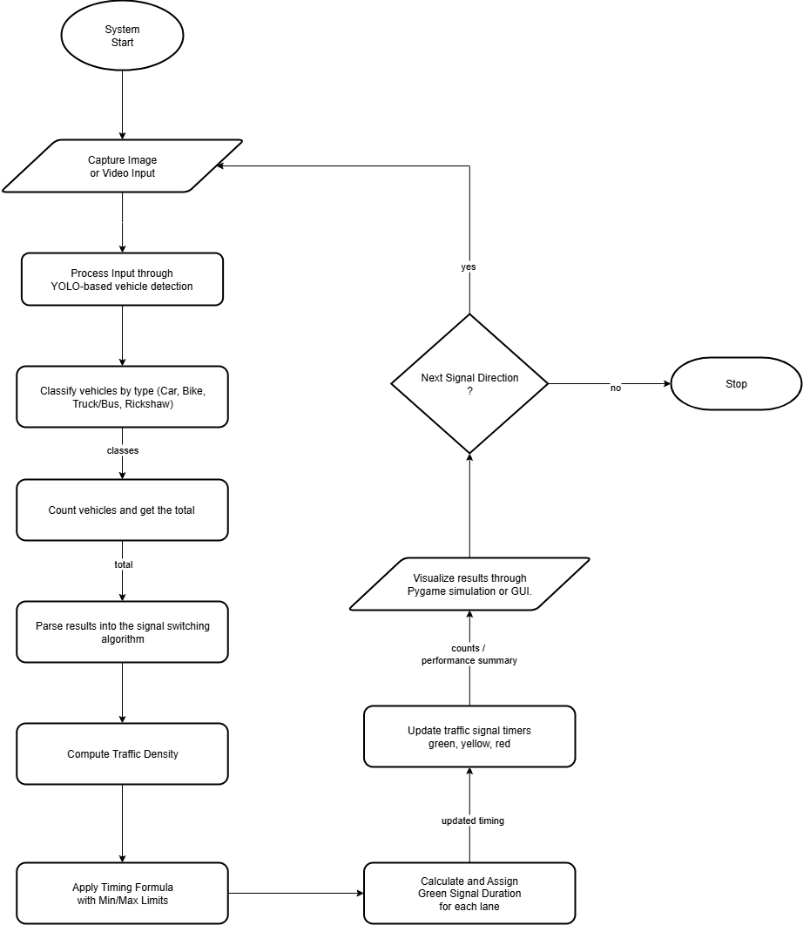
Figure 4. 1: Proposed System Operation Flowchart

This flow ensures that each module operates sequentially and contributes to the intelligent decision-making of the overall system.

4.4 USE CASE DESCRIPTION
The use-case diagram of the system highlights the interaction between different actors and the functionalities provided by the system.
Key Actors:
- Traffic System Operator: Interacts with the GUI to run detections on traffic images or videos, monitors results, and configures detection parameters.
- Detection Module (YOLO): Processes input images or video frames and provides output in terms of detected vehicles and their classifications.
- Signal Control Module: Uses detection outputs to compute adaptive signal durations.
- Simulation Module: Displays a four-way traffic intersection, signal timers, and vehicle flows in real time.
Primary Use Cases:
- Run Vehicle Detection: User selects image or video files through the GUI, and the system detects and counts vehicles.
- Optimize Detection Parameters: User adjusts GUI controls (confidence thresholds, frame skips, tracking settings) to improve performance.
- Adaptive Signal Timing: The algorithm updates green light durations based on traffic density.
- Simulate Traffic Flow: The simulation module visualizes adaptive behavior in a realistic intersection environment.
- View Results: Users can view detection outputs, counts, and signal durations in both GUI and simulation displays.

4.5 PROCESSING AND SYSTEM MODULES DESIGN
The system was designed in modular form, with each module responsible for a specific task. This modular approach simplifies development, testing, and maintenance, while also ensuring that individual modules can be enhanced independently without affecting the overall system.
4.5.1 VEHICLE DETECTION MODULE
This module leverages the YOLO (You Only Look Once) deep learning framework for real-time vehicle detection and classification. The trained model can detect four vehicle classes: cars, bikes, buses/trucks, and rickshaws. For video input, a tracking algorithm ensures persistent identification of vehicles across frames, preventing double counting.
4.5.2 SIGNAL SWITCHING ALGORITHM
The signal switching algorithm is at the core of the adaptive traffic system. It parses vehicle detection results and computes the appropriate green signal duration for each lane. To ensure fairness and prevent starvation of lanes, both minimum and maximum green time limits are imposed.
The adaptive green signal time (GST) is calculated using the following formula:
$$GST=\frac{∑\left(Ni​×Ti​\right)​}{L}$$
Where:
- Ni​​ = Number of vehicles of class i detected in a given lane.
- Ti​​ = Average time required for a vehicle of class i to cross the intersection.
- L = Number of lanes at the intersection.
For example, if a lane contains 10 cars, 3 buses, and 5 bikes, and the average crossing times are 2 seconds for a car, 5 seconds for a bus, and 1.5 seconds for a bike, then the calculated green time will proportionally reflect the weighted requirements of each class.
Additional constraints are applied:
- Minimum green time ($GSTmin$​) ensures that even low-density lanes receive sufficient crossing time.
- Maximum green time (GSTmax​​) prevents monopolization of the intersection by any single congested lane.
This hybrid approach balances fairness with efficiency, ensuring optimal utilization of intersection capacity.
4.5.3 SIMULATION MODULE
The simulation module uses Pygame to replicate a four-way intersection. Detected vehicle counts are used to determine green times, which are displayed as traffic light countdowns. Vehicles of different classes are represented visually, and their speeds differ according to average crossing times.
4.5.4 GRAPHICAL USER INTERFACE (GUI) MODULE
The GUI, implemented in detector_all.py, provides a user-friendly way of running detection on images and videos. Users can adjust detection thresholds, set frame skip values, and tweak tracker parameters to optimize results. The interface displays live statistics such as frame rate, per-class vehicle counts, and overall vehicle flow.

4.6 DATABASE DESIGN
This project does not rely on a traditional database for persistent storage, since its purpose is primarily detection, computation, and simulation. However, for extensibility, a basic storage mechanism was implemented to save results of detections in structured text files or logs.
Structure of Detection Results File:
- Timestamp – the date and time of detection.
- Input Source – image or video file path.
- Detected Classes – the list of vehicle categories (car, bus, truck, bike, rickshaw).
- Vehicle Counts – total number of vehicles per class.
- Processing Parameters – confidence threshold, IoU, frame skip used.
This lightweight file-based approach ensures results can be revisited or analyzed later, without introducing unnecessary database complexity.
4.7 SYSTEM ENVIRONMENT SPECIFICATIONS
The system environment specifies the hardware, software, and network tools used during development and deployment.
4.7.1 HARDWARE REQUIREMENTS
- Processor: Intel Core i5 (2.4 GHz) or higher.
- RAM: Minimum 8 GB.
- Storage: 500 GB free space (for datasets, YOLO weights, and simulation files).
- GPU: NVIDIA CUDA-enabled GPU (optional but recommended for YOLO acceleration).
- Display: 1366x768 resolution or higher.
4.7.2 SOFTWARE REQUIREMENTS
- Operating System: Windows 10 / Linux (Ubuntu 20.04) / macOS.
- Programming Language: Python 3.8 or higher.
- Frameworks and Libraries:
  - OpenCV for image and video processing.
  - YOLO/Darkflow for object detection.
  - Pygame for simulation visualization.
  - Tkinter/PyQt for GUI development.
  - Numpy for data handling.
- IDE: Visual Studio Code or PyCharm.
4.7.3 NETWORK REQUIREMENTS
The current project does not require an external network for its operation. However, in future extensions, real-time CCTV feeds could be streamed over a local network or cloud environment to integrate live detection.

4.8 IMPLEMENTATION STAGES
Software Implementation is a process carried out to make changes to the tested programs developed in the system. The software will be installed successfully if the hardware requirement and the software requirement are available. The following phase contains how the software was implemented successfully;
4.8.1 SYSTEM INITIALIZATION
The environment was set up by installing Python and the required libraries. YOLO pre-trained weights were downloaded and configured in the system. The project structure was organized into modules for detection, simulation, and GUI.
4.8.2 VEHICLE DETECTION MODULE
This module was implemented using YOLO for detecting objects within an image or video frame. A custom-trained YOLO model was used to identify cars, bikes, buses/trucks, and rickshaws. The detection outputs were returned in JSON format, containing bounding box coordinates, class labels, and confidence scores. OpenCV was integrated to render bounding boxes visually.
4.8.3 SIGNAL SWITCHING ALGORITHM
The algorithm parsed vehicle counts from the detection module and calculated adaptive green signal durations using weighted average crossing times. Constraints were applied to ensure a minimum and maximum green time per lane. This approach ensures fairness while prioritizing lanes with higher traffic density.
4.8.4 SIMULATION MODULE
Using Pygame, a virtual four-way intersection was created. Vehicles were randomly generated in different lanes and controlled by the adaptive signal logic. The simulation displayed signal states, countdown timers, vehicle counts, and elapsed time. Turning movements and varying speeds per vehicle type were incorporated to increase realism.
4.8.5 GRAPHICAL USER INTERFACE (GUI) FOR DETECTION
The new GUI, implemented in detector_all.py, extended the system’s usability by allowing detection and counting of vehicles from both images and videos. The GUI included controls for confidence threshold, frame skip, tracker parameters, and display options. A tracking algorithm ensured that vehicles were uniquely identified across frames, preventing double counting. Real-time statistics, including FPS and total vehicle counts, were displayed for user convenience.

4.9 USER TRAINING STAGE
Before the user can effectively operate the smart traffic management system, it is necessary to provide thorough training on how to use both the simulation environment and the graphical user interface (GUI) for vehicle detection. The main users of the software are system operators or researchers who will interact with the program. Training involves step-by-step tutorials and demonstrations designed to ensure smooth operation of the software modules.
Once the system was developed, user training was conducted to familiarize operators with the program. This involved:
- Demonstrating how to launch the simulation and GUI.
- Explaining how to load traffic data (images/videos).
- Showing how to adjust detection parameters for optimal performance.
- Training operators to interpret outputs and results correctly.
The following steps would help train and guide the users on how to use the program effectively:
Simulation Module:
- On the operator’s PC, navigate to the simulation script (simulation_v2.py) and open it with a code editor such as VS Code.
- Open the terminal and run the command: python simulation_v2.py
- If successful, a Pygame window opens showing a four-way intersection.
- Observe the adaptive traffic signals (green, yellow, red) and how timers adjust dynamically based on detection results.
- Use the close button or CTRL + C in the terminal to exit the simulation.
GUI Detection Module (detector_all.py):
- On the operator’s PC, navigate to the detection script (detector_all.py).
- Open a terminal and run the command: python detector_all.py
- When the GUI window opens, click Load Image or Load Video to select traffic input files.
- Click Run Detection to begin vehicle detection and counting. Bounding boxes will appear on detected vehicles with live statistics displayed.
- To optimize performance, adjust parameters on the side panel such as confidence threshold, frame skip, and tracker settings.
- Use the save summary option to export detection results to a text file for later review.
- To close the program, simply exit the GUI window.
Through this structured training, operators are able to confidently run the system without prior expertise in programming or computer vision.

4.10 INTERFACE OF THE SYSTEM
The system’s interface consists of two major interactive outputs:
4.10.1 GRAPHICAL USER INTERFACE (GUI) FOR VEHICLE DETECTION
This interface allows the user to browse and load image or video files. Detection results are shown on the display, with bounding boxes around vehicles, and real-time counts of detected objects. On the side panel, controls are available to modify detection thresholds, enable or disable tracking, and view FPS statistics.
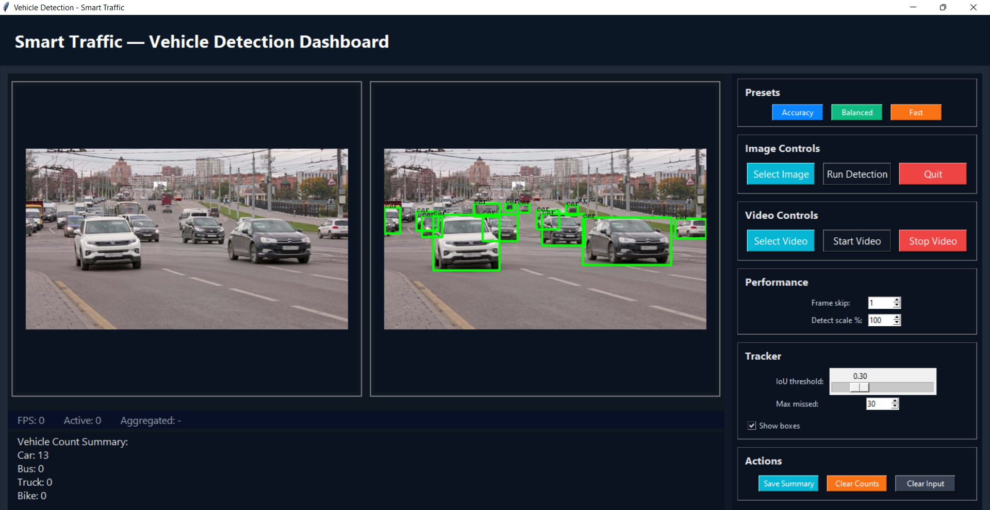
Figure 4. 2: Real-time Vehicle Detection Dashboard

4.10.2 SIMULATION INTERFACE (PYGAME)
The simulation interface depicts a four-way intersection with vehicles moving in each direction. Traffic lights above each lane display the current state (red, yellow, or green) along with the timer countdown. The number of vehicles that have crossed each signal is shown on screen, and traffic flow adapts dynamically based on signal timings calculated from the detection module.
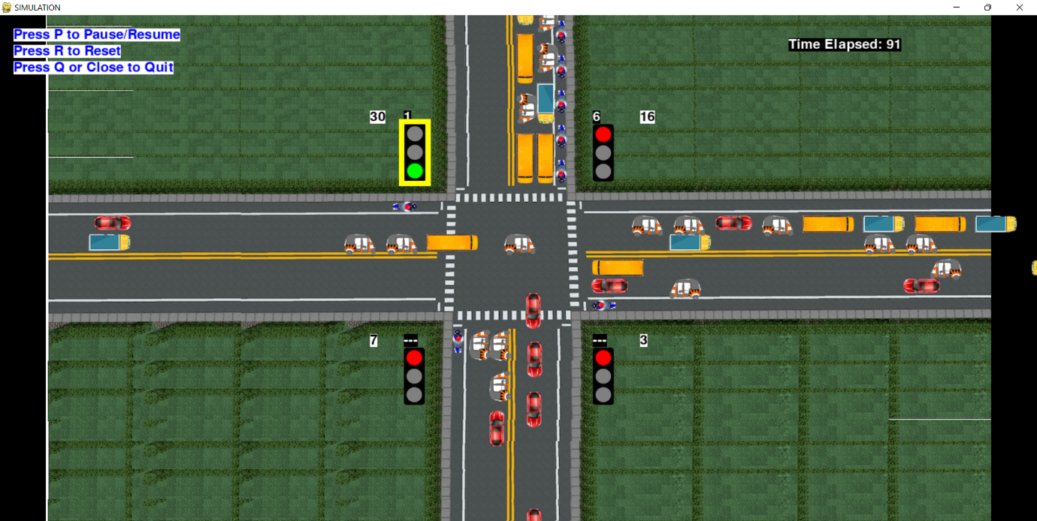
Figure 4. 3: Simulation of Traffic System
Together, these interfaces make the system accessible and practical for demonstration.

4.11 TESTING
Testing was carried out in two phases: unit testing and integration testing.
Unit Testing: Each module was tested independently. The detection module was tested with images and videos to confirm accuracy of classification and counting. The algorithm was tested with different vehicle counts to ensure proper computation of green signal durations. The simulation was tested by running multiple cycles to verify correct switching of lights and realistic vehicle flow.
Integration Testing: After confirming the functionality of individual modules, they were integrated into a single system. Test scenarios were designed to validate that detection outputs correctly influenced signal timings, and that both simulation and GUI displayed consistent results. The GUI was further tested for responsiveness and correctness of real-time statistics.
The results of these tests demonstrated that the system performed as expected, achieving accurate vehicle detection, logical adaptive signal timing, and effective visual simulation. At this stage, the system was considered ready for deployment as a prototype.

CHAPTER FIVE
SUMMARY, CONCLUSION AND RECOMMENDATION
5.1 INTRODUCTION
This chapter presents the concluding aspects of the research work on the design and implementation of a smart traffic management system using computer vision. It brings together the entire study by summarizing the key activities carried out, the methods employed, and the findings that emerged from the implementation of the system. The chapter also provides conclusions drawn from the results, showing how the system has met the objectives that were set at the beginning of the research.
In addition to the summary and conclusion, this chapter highlights the relevance of the system to the broader field of intelligent transportation systems and its potential for real-world deployment in urban centers. Finally, it offers recommendations on how the system can be improved, scaled, and integrated into existing traffic infrastructures, while also suggesting areas of future research that could build upon the foundation laid by this project.

5.2 SUMMARY
The problem of traffic congestion remains one of the most pressing challenges in urban centers worldwide. Conventional fixed-time traffic light systems, though simple and inexpensive, fail to adapt to real-time traffic variations. As a result, they contribute to unnecessary delays, fuel wastage, environmental pollution, and increased driver frustration. This study was initiated to explore how modern technologies—specifically computer vision and intelligent algorithms—can be harnessed to address these challenges.
The project was guided by the aim of designing and implementing a smart traffic management system using computer vision. To achieve this aim, the following objectives were set: developing a vehicle detection system using pre-trained YOLO models; creating an adaptive traffic signal timing algorithm; simulating the adaptive signal system in a virtual intersection using Pygame; and designing a GUI for vehicle detection and counting from both images and videos.
The research methodology followed the Waterfall model, which allowed a structured approach to requirements gathering, design, implementation, and testing. A dataset of traffic images was prepared and annotated, and YOLO (You Only Look Once) was adopted as the detection framework due to its efficiency in real-time object detection. The adaptive algorithm employed a weighted formula that calculated green signal time based on the number and types of vehicles detected in a lane.
System implementation was divided into modules. The vehicle detection module successfully identified and classified vehicles into four categories: cars, bikes, buses/trucks, and rickshaws. The signal switching module dynamically calculated green light durations based on weighted vehicle counts. The simulation module demonstrated adaptive traffic control at a four-way intersection, visually representing how the system would behave in a real-world environment. Finally, the graphical user interface (GUI) provided a user-friendly platform for running detection on images and videos, offering controls to optimize detection parameters and presenting real-time statistics.
Testing and evaluation showed that the system achieved the objectives of the study. Vehicle detection was accurate for the specified classes, the adaptive algorithm adjusted green times logically in response to varying traffic densities, and the simulation illustrated how adaptive signals reduce idle time compared to fixed-timer systems. The GUI further extended usability by allowing operators to interact with the system without requiring coding knowledge.
In summary, this research successfully demonstrated that integrating computer vision with traffic management can significantly improve signal efficiency, reduce congestion, and serve as a foundation for real-world smart city solutions.

5.3 CONCLUSION
The research demonstrates that traditional fixed-time traffic systems are inadequate for modern urban traffic management, as they cannot respond to real-time variations in vehicle flow. By leveraging computer vision and intelligent algorithms, traffic signals can be made adaptive, efficient, and responsive.
The system designed in this study illustrates the feasibility of such an approach. Using YOLO-based detection, the system accurately counted and classified vehicles from images and videos. The adaptive green signal timing algorithm allocated green time proportionally to the detected traffic density, ensuring fairness across lanes while reducing unnecessary waiting times. The simulation module validated the concept by providing a visual representation of adaptive traffic flow. Furthermore, the GUI provided an interactive platform for detection, making the system more practical and accessible to users.
The study concludes that adaptive traffic management systems based on computer vision are a viable and cost-effective approach to mitigating congestion, especially in developing countries where infrastructure upgrades are limited. Although this system remains a prototype, it provides a strong foundation for deployment in real-world scenarios with the integration of live camera feeds and physical traffic controllers.

5.4 RECOMMENDATION
Based on the outcome of this research, the following recommendations are made for the enhancement and practical application of the system:
- Integration with Live Feeds: The system should be extended to process real-time video streams from CCTV cameras at intersections. This will allow immediate responsiveness to changing traffic conditions.
- Hardware Deployment: Future development should focus on integrating the software with actual traffic light hardware to validate performance in live environments. This could involve microcontrollers or IoT-enabled devices connected to traffic lights.
- Extended Vehicle Classes: While the current system detects cars, bikes, buses/trucks, and rickshaws, further classes such as pedestrians, emergency vehicles, and bicycles should be included. This will ensure inclusivity and prioritize emergency services when necessary.
- Scalability to Larger Networks: The system currently models a four-way intersection. Expanding the system to cover larger, multi-lane intersections and entire road networks would make it more representative of real-world city traffic.
- Optimization for Edge Devices: To make the system affordable and deployable at scale, it should be optimized to run on low-cost embedded devices such as Raspberry Pi or NVIDIA Jetson boards, enabling deployment in resource-constrained regions.
- Improved Data Management: While this project used lightweight text file storage, a structured database could be introduced to maintain logs of detections, signal adjustments, and performance metrics over time for analysis.
- User-Centric Training and Documentation: Continuous training for traffic operators should be incorporated to ensure smooth adoption of the system. Clear documentation and troubleshooting guides would further enhance usability.
In conclusion, this study not only contributes to academic knowledge but also provides a practical prototype for real-world traffic management applications. Implementing the recommendations outlined above will bridge the gap between simulation and actual deployment, moving closer to achieving the vision of intelligent, congestion-free urban transportation systems.

REFERENCES
Abdoos, M., Mozayani, N., & Bazzan, A. L. (2014). Traffic light control in non-stationary environments based on multi-agent Q-learning. IEEE Transactions on Intelligent Transportation Systems, 15(2), 581–592. https://doi.org/10.1109/TITS.2013.2283511
Djahel, S., Salehie, M., Tal, I., & Jamshidi, S. (2015). A communications-oriented perspective on traffic management systems for smart cities: Challenges and innovative approaches. IEEE Communications Surveys & Tutorials, 17(1), 125–151. https://doi.org/10.1109/COMST.2014.2339816
Gupta, D., & Tiwari, M. K. (2017). Intelligent traffic control system using image processing. International Journal of Computer Applications, 975, 8887. https://doi.org/10.5120/ijca2017914364
Jiang, Y., & He, Z. (2019). Smart traffic management system: A review of applications and future research directions. Transportation Research Part C: Emerging Technologies, 102, 140–159. https://doi.org/10.1016/j.trc.2019.03.026
Kumar, A., & Kumar, M. (2020). Smart traffic management system using computer vision: A review. International Journal of Engineering Research & Technology, 8(4), 45–52.
Li, L., Li, Y., & Wang, F. Y. (2014). Traffic signal timing via deep reinforcement learning. IEEE/CAA Journal of Automatica Sinica, 3(3), 247–254. https://doi.org/10.1109/JAS.2016.7508798
Liu, H., Zhang, X., & Wang, Y. (2020). Intelligent traffic systems in urban areas: Case studies from Singapore. Journal of Urban Technology, 27(3), 44–56. https://doi.org/10.1080/10630732.2020.1753456
Olamide, O. (2023, July 12). Lagos economy in ‘go-slow’ as traffic disappears. BusinessDay. https://businessday.ng/news/article/lagos-economy-in-go-slow-as-traffic-disappears/
Olaru, V., & Mohor, A. (2018). Intelligent traffic management system. Journal of Traffic and Logistics Engineering, 6(1), 34–39. https://doi.org/10.18178/jtle.6.1.34-39
Redmon, J., Divvala, S., Girshick, R., & Farhadi, A. (2016). You only look once: Unified, real-time object detection. In Proceedings of the IEEE Conference on Computer Vision and Pattern Recognition (CVPR) (pp. 779–788). https://doi.org/10.1109/CVPR.2016.91
Ren, S., He, K., Girshick, R., & Sun, J. (2017). Faster R-CNN: Towards real-time object detection with region proposal networks. IEEE Transactions on Pattern Analysis and Machine Intelligence, 39(6), 1137–1149. https://doi.org/10.1109/TPAMI.2016.2577031
Satzinger, J. W., Jackson, R. B., & Burd, S. D. (2015). Systems analysis and design in a changing world (7th ed.). Cengage Learning.
Schrank, D., Eisele, B., & Lomax, T. (2021). 2021 urban mobility report. Texas A&M Transportation Institute. https://mobility.tamu.edu/umr/
Shah, S., Khan, I., & Khan, R. (2021). Adaptive traffic signal systems using computer vision. IEEE Transactions on Intelligent Transportation Systems, 22(4), 2521–2532. https://doi.org/10.1109/TITS.2020.3001234
Zhang, W., Li, M., & Zhao, J. (2022). Computer vision for urban traffic management: A comprehensive survey. Journal of Artificial Intelligence Research, 55(1), 78–102. https://doi.org/10.1613/jair.1.13229
Zhang, Y., Xie, Y., Lu, J. J., & Wang, X. (2011). Development and evaluation of an adaptive signal control system for arterial corridors. Transportation Research Record: Journal of the Transportation Research Board, 2259(1), 34–44. https://doi.org/10.3141/2259-04

APPENDIX A
“SOURCE CODE – VEHICLE DETECTION MODULE”

import tkinter as tk
from tkinter import filedialog, Label, Button, Frame, messagebox
from PIL import Image, ImageTk
import os
import cv2
import numpy as np
from vehicle_detection_2 import detectVehicles, tfnet
import threading
import time
import math

class SimpleTracker:
"""Lightweight IoU-based tracker to assign persistent IDs to detections.
Not a full SORT implementation but suitable for unique counting across frames.
"""
def __init__(self, iou_threshold=0.3, max_missed=30):
self.next_id = 1
self.tracks = {} # id -> {bbox, label, missed}
self.iou_threshold = iou_threshold
self.max_missed = max_missed
self.unique_ids = {} # label -> set(ids)

@staticmethod
def iou(boxA, boxB):
# boxes: (x1,y1,x2,y2)
xA = max(boxA[0], boxB[0])
yA = max(boxA[1], boxB[1])
xB = min(boxA[2], boxB[2])
yB = min(boxA[3], boxB[3])
interW = max(0, xB - xA)
interH = max(0, yB - yA)
interArea = interW * interH
boxAArea = max(0, boxA[2] - boxA[0]) * max(0, boxA[3] - boxA[1])
boxBArea = max(0, boxB[2] - boxB[0]) * max(0, boxB[3] - boxB[1])
denom = float(boxAArea + boxBArea - interArea)
if denom <= 0:
return 0.0
return interArea / denom

def update(self, detections):
"""detections: list of (x1,y1,x2,y2,label)
returns list of tracks (id, bbox, label)
"""
matches = {}
used_dets = set()
# Build IoU matrix between existing tracks and detections
track_ids = list(self.tracks.keys())
iou_matrix = []
for tid in track_ids:
row = []
for det in detections:
row.append(self.iou(self.tracks[tid]['bbox'], det[:4]))
iou_matrix.append(row)

# Greedy matching by highest IoU
for _ in range(min(len(track_ids), len(detections))):
best_val = 0
best_t = None
best_d = None
for ti, tid in enumerate(track_ids):
for di, det in enumerate(detections):
if di in used_dets or tid in matches:
continue
val = iou_matrix[ti][di]
# require same label to match
if val > best_val and det[4] == self.tracks[tid]['label']:
best_val = val
best_t = tid
best_d = di
if best_val >= self.iou_threshold and best_t is not None:
matches[best_t] = best_d
used_dets.add(best_d)
else:
break

# Update matched tracks
for tid, di in matches.items():
det = detections[di]
self.tracks[tid]['bbox'] = det[:4]
self.tracks[tid]['missed'] = 0

# Increment missed for unmatched tracks
for tid in list(self.tracks.keys()):
if tid not in matches:
self.tracks[tid]['missed'] += 1
if self.tracks[tid]['missed'] > self.max_missed:
del self.tracks[tid]

# Create new tracks for unmatched detections
for di, det in enumerate(detections):
if di in used_dets:
continue
bbox = det[:4]
label = det[4]
tid = self.next_id
self.next_id += 1
self.tracks[tid] = {'bbox': bbox, 'label': label, 'missed': 0}
self.unique_ids.setdefault(label, set()).add(tid)

# Return current active tracks
out = []
for tid, t in self.tracks.items():
out.append((tid, t['bbox'], t['label']))
return out

def get_unique_counts(self):
return {k: len(v) for k, v in self.unique_ids.items()}

class VehicleDetectionApp:
def __init__(self, root):
self.root = root
self.root.title("Vehicle Detection - Smart Traffic")
self.root.configure(bg="#1f2937")
self.root.geometry("1100x720")
self.root.minsize(1000, 640)

self.selected_image_path = None
self.output_image_path = None
self.summary = ""

# Top banner / title
banner = Frame(root, bg="#0b1724", height=80)
banner.pack(fill="x")
title = Label(banner, text="Smart Traffic — Vehicle Detection Dashboard", font=("Segoe UI", 20, "bold"), fg="#ffffff", bg="#0b1724")
title.pack(padx=20, pady=18, anchor="w")

# Main area: left = images, right = controls
main = Frame(root, bg="#111827")
main.pack(fill="both", expand=True, padx=12, pady=12)

# Left column: images and timeline/stats
left_col = Frame(main, bg="#0f1720")
left_col.pack(side="left", fill="both", expand=True, padx=(0,12))

# Image display row (original / annotated)
images_row = Frame(left_col, bg="#0f1720")
images_row.pack(fill="both", expand=True, pady=(6,10))

self.img_frame = Frame(images_row, bg="#0f1720", bd=2, relief="ridge")
self.img_frame.pack(side="left", fill="both", expand=True, padx=(6,6), pady=6)
self.img_label = Label(self.img_frame, bg="#0b1220")
self.img_label.pack(fill="both", expand=True, padx=6, pady=6)

self.out_frame = Frame(images_row, bg="#0f1720", bd=2, relief="ridge")
self.out_frame.pack(side="left", fill="both", expand=True, padx=(6,6), pady=6)
self.out_label = Label(self.out_frame, bg="#0b1220")
self.out_label.pack(fill="both", expand=True, padx=6, pady=6)

# Bottom-left: live stats strip
stats_strip = Frame(left_col, bg="#071027", height=80)
stats_strip.pack(fill="x", pady=(6,0))
self.fps_label = Label(stats_strip, text="FPS: 0", font=("Segoe UI", 12), fg="#9ca3af", bg="#071027")
self.fps_label.pack(side="left", padx=12)
self.active_tracks_label = Label(stats_strip, text="Active: 0", font=("Segoe UI", 12), fg="#9ca3af", bg="#071027")
self.active_tracks_label.pack(side="left", padx=12)
self.agg_label = Label(stats_strip, text="Aggregated: -", font=("Segoe UI", 12), fg="#9ca3af", bg="#071027")
self.agg_label.pack(side="left", padx=12)

# Right column: controls / presets / actions
ctrl_col = Frame(main, bg="#0b1220", width=360)
ctrl_col.pack(side="right", fill="y")

# Presets card
preset_card = Frame(ctrl_col, bg="#0b1220", bd=1, relief="groove")
preset_card.pack(fill="x", padx=8, pady=(8,6))
Label(preset_card, text="Presets", font=("Segoe UI", 12, "bold"), fg="#e5e7eb", bg="#0b1220").pack(anchor="w", padx=8, pady=6)
pbtn_row = Frame(preset_card, bg="#0b1220")
pbtn_row.pack(padx=8, pady=(0,8))
APPENDIX B
“SOURCE CODE – SIMULATION MODULE”

# LAG
# NO. OF VEHICLES IN SIGNAL CLASS
# stops not used
# DISTRIBUTION
# BUS TOUCHING ON TURNS
# Distribution using python class

# *** IMAGE XY COOD IS TOP LEFT
import random
import math
import time
import threading
# from vehicle_detection import detection
import pygame
import sys
import os

# options={
# 'model':'./cfg/yolo.cfg', #specifying the path of model
# 'load':'./bin/yolov2.weights', #weights
# 'threshold':0.3 #minimum confidence factor to create a box, greater than 0.3 good
# }

# tfnet=TFNet(options) #READ ABOUT TFNET

show_summary = None # Will hold summary_lines when simulation ends

# =============================
# Default values of signal times
# =============================
defaultRed = 150
defaultYellow = 5
defaultGreen = 20
defaultMinimum = 10
defaultMaximum = 60

signals = []
noOfSignals = 4
simTime = 300 # change this to change time of simulation 300
timeElapsed = 0

currentGreen = 0 # Indicates which signal is green
nextGreen = (currentGreen+1)%noOfSignals
currentYellow = 0 # Indicates whether yellow signal is on or off

# Average times for vehicles to pass the intersection
carTime = 2
bikeTime = 1
rickshawTime = 2.25
busTime = 2.5
truckTime = 2.5

# Count of cars at a traffic signal
noOfCars = 0
noOfBikes = 0
noOfBuses =0
noOfTrucks = 0
noOfRickshaws = 0
noOfLanes = 2

# Red signal time at which cars will be detected at a signal
detectionTime = 5

speeds = {'car':2.25, 'bus':1.8, 'truck':1.8, 'rickshaw':2, 'bike':2.5} # average speeds of vehicles

# Coordinates of start
x = {'right':[0,0,0], 'down':[755,727,697], 'left':[1400,1400,1400], 'up':[602,627,657]}
y = {'right':[348,370,398], 'down':[0,0,0], 'left':[498,466,436], 'up':[800,800,800]}

vehicles = {'right': {0:[], 1:[], 2:[], 'crossed':0}, 'down': {0:[], 1:[], 2:[], 'crossed':0}, 'left': {0:[], 1:[], 2:[], 'crossed':0}, 'up': {0:[], 1:[], 2:[], 'crossed':0}}
vehicleTypes = {0:'car', 1:'bus', 2:'truck', 3:'rickshaw', 4:'bike'}
directionNumbers = {0:'right', 1:'down', 2:'left', 3:'up'}

# Coordinates of signal image, timer, and vehicle count
signalCoods = [(530,230),(810,230),(810,570),(530,570)]
signalTimerCoods = [(530,210),(810,210),(810,550),(530,550)]
vehicleCountCoods = [(480,210),(880,210),(880,550),(480,550)]
vehicleCountTexts = ["0", "0", "0", "0"]

# Coordinates of stop lines
stopLines = {'right': 590, 'down': 330, 'left': 800, 'up': 535}
defaultStop = {'right': 580, 'down': 320, 'left': 810, 'up': 545}
stops = {'right': [580,580,580], 'down': [320,320,320], 'left': [810,810,810], 'up': [545,545,545]}

mid = {'right': {'x':705, 'y':445}, 'down': {'x':695, 'y':450}, 'left': {'x':695, 'y':425}, 'up': {'x':695, 'y':400}}
rotationAngle = 3

# Gap between vehicles
gap = 15 # stopping gap
gap2 = 15 # moving gap

pygame.init()
simulation = pygame.sprite.Group()

class TrafficSignal:
"""
Represents a traffic signal with its timing and state.
"""
def __init__(self, red, yellow, green, minimum, maximum):
self.red = red
self.yellow = yellow
self.green = green
self.minimum = minimum
self.maximum = maximum
self.signalText = "30"
self.totalGreenTime = 0

class Vehicle(pygame.sprite.Sprite):
"""
Represents a vehicle in the simulation.
"""
def __init__(self, lane, vehicleClass, direction_number, direction, will_turn):
super().__init__()
self.lane = lane
self.vehicleClass = vehicleClass
self.speed = speeds[vehicleClass]
self.direction_number = direction_number
self.direction = direction
self.x = x[direction][lane]
self.y = y[direction][lane]
self.crossed = 0
self.willTurn = will_turn
self.turned = 0
self.rotateAngle = 0
vehicles[direction][lane].append(self)
self.index = len(vehicles[direction][lane]) - 1
path = "images/" + direction + "/" + vehicleClass + ".png"
self.originalImage = pygame.image.load(path)
self.currentImage = pygame.image.load(path)
# Set stop position
if direction == 'right':
if len(vehicles[direction][lane]) > 1 and vehicles[direction][lane][self.index-1].crossed == 0:
self.stop = vehicles[direction][lane][self.index-1].stop - vehicles[direction][lane][self.index-1].currentImage.get_rect().width - gap
else:
self.stop = defaultStop[direction]
temp = self.currentImage.get_rect().width + gap
x[direction][lane] -= temp
stops[direction][lane] -= temp
elif direction == 'left':
if len(vehicles[direction][lane]) > 1 and vehicles[direction][lane][self.index-1].crossed == 0:
self.stop = vehicles[direction][lane][self.index-1].stop + vehicles[direction][lane][self.index-1].currentImage.get_rect().width + gap
else:
self.stop = defaultStop[direction]
temp = self.currentImage.get_rect().width + gap

